**02/11/2021 CD SPOT 8 2019103573**

**1.Write a yacc program to implement relational operators**

**CODE :-**

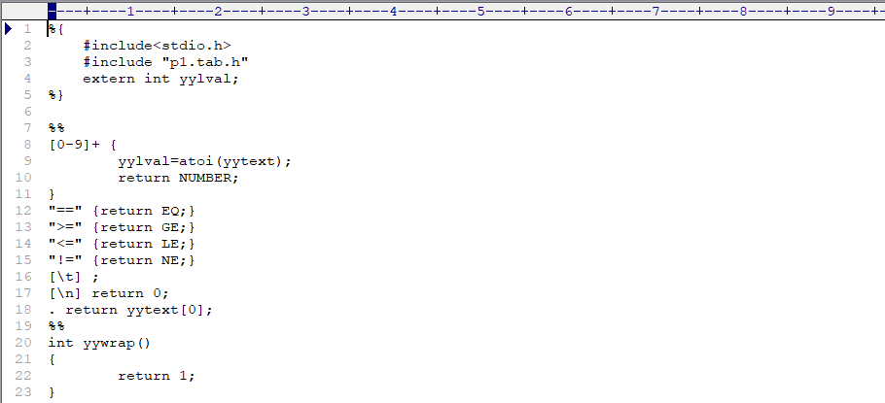**lex**

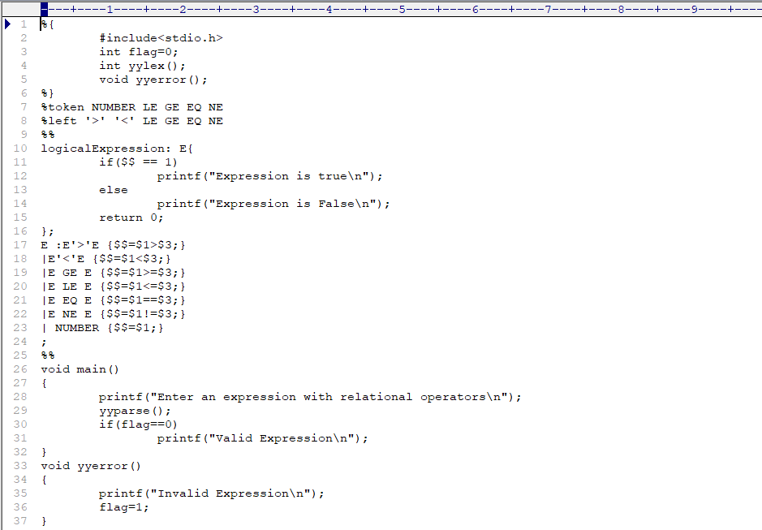**yacc**

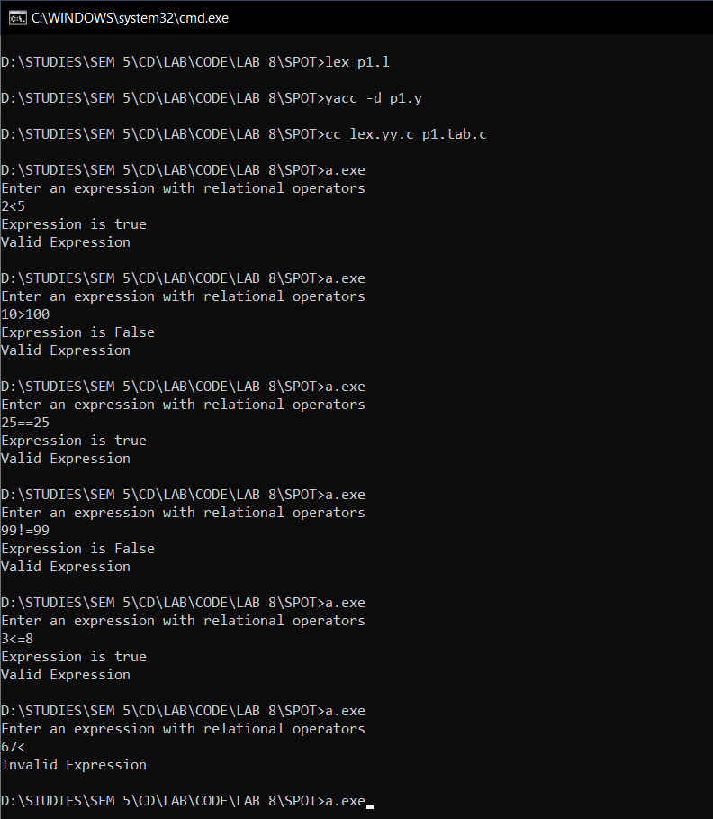**OUTPUT :-**

**2.Write a yacc program to verify the syntax of the given if-else statements**

**CODE :-**

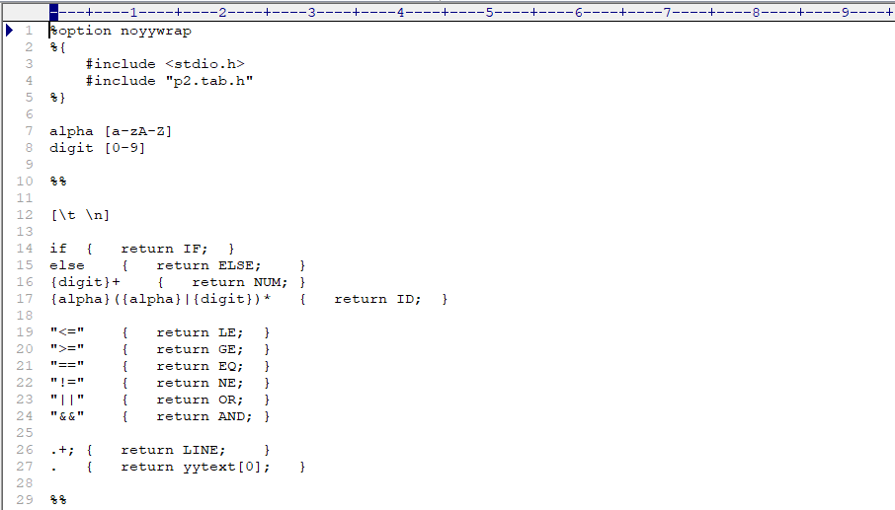**lex**

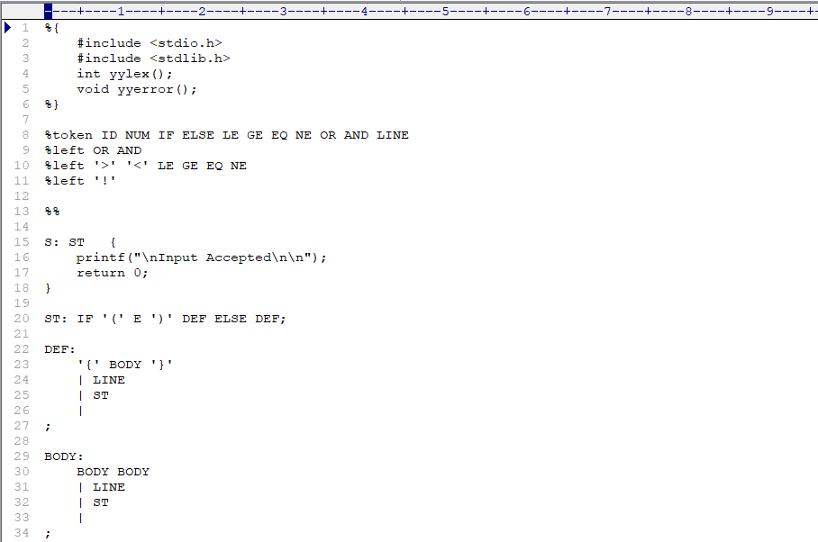

**yacc**

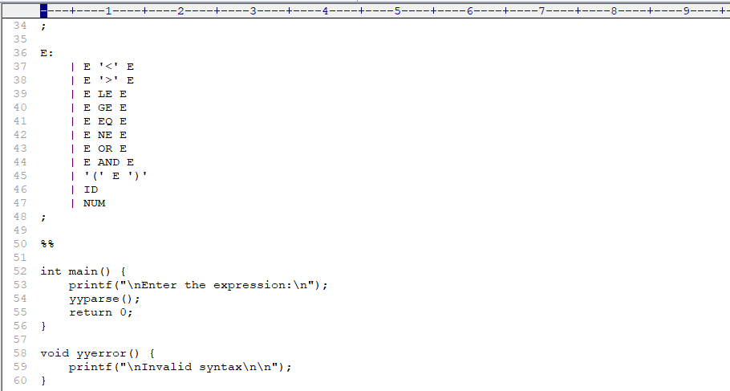

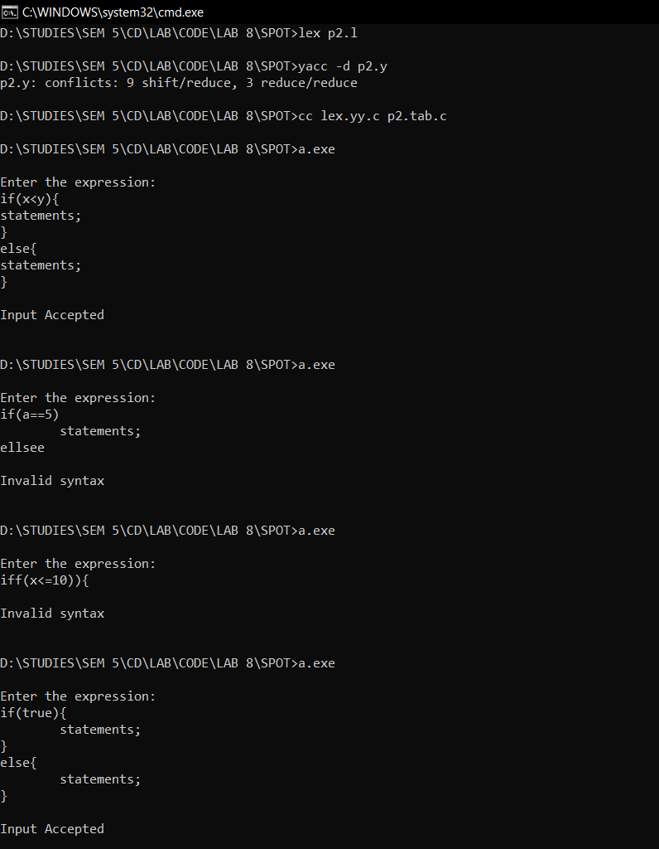**OUTPUT :-**

